**Generate a random Numpy array of shape (500,) based on a given sentence.**

**Approach:**

* Create a function that takes a sentence as input and generates a random Numpy array of shape shape (500,) using the sentence to seed the random number generator. The sentence is hased to produce a seed for generating reproducible random numbers.
* Seed () method used to initialize the random number generator.
* Hash used to get the unique values from the given string input and covert into 32 bit range.
* Parameters: sentence (str) : The input sentence used to seed the random number generator.
* Returns: np. Ndarray: A numpy array of shape (500,) containing random floating–point values.
* Error Validation: 1.Type Error: If the input sentence is not a string. 2. If the input string is not a sentence.
* Deployed in flask web framework and tested in Postman.

**Assumptions:**

* Single word not allowed
* Blanks are not allowed
* Special characters and numbers shouldn’t be present in input sentence.
* Multiple sentences comma and full stop to be converted into spaces and then sentences converted into array.

**Validations:**

**Positive Test Cases:**

Case 1: Small Sentence: ”Hello world”

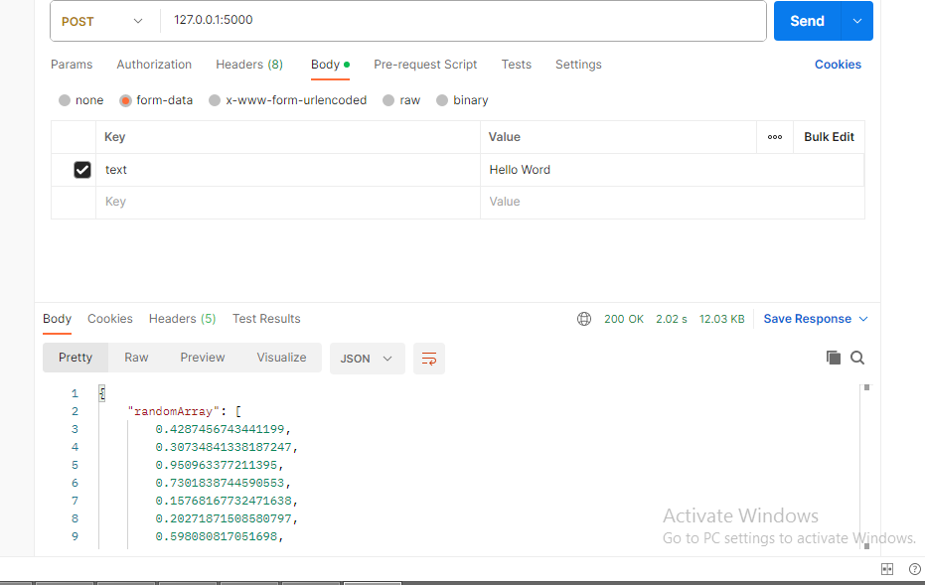

Case 2: Large Sentence: “Preqin is a data led research trends and events in the alternative assets industry”

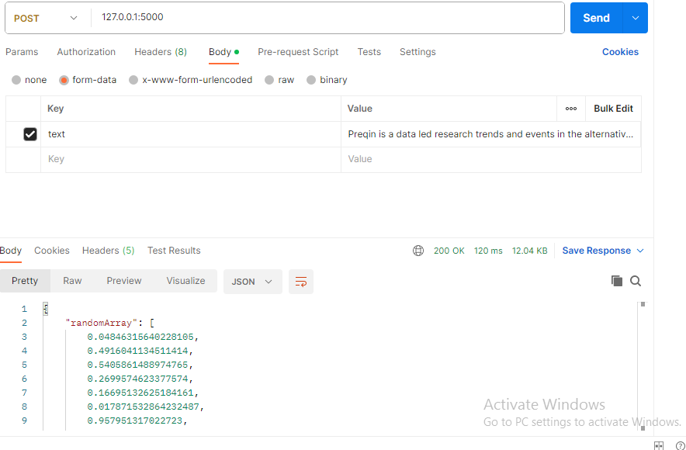

* Case 3: Multiple sentences comma and full stop to be converted into spaces and then sentences converted into array. Input sentences -> “At its simplest form, artificial intelligence is a field, which combines computer science and robust datasets, to enable problem solving.”

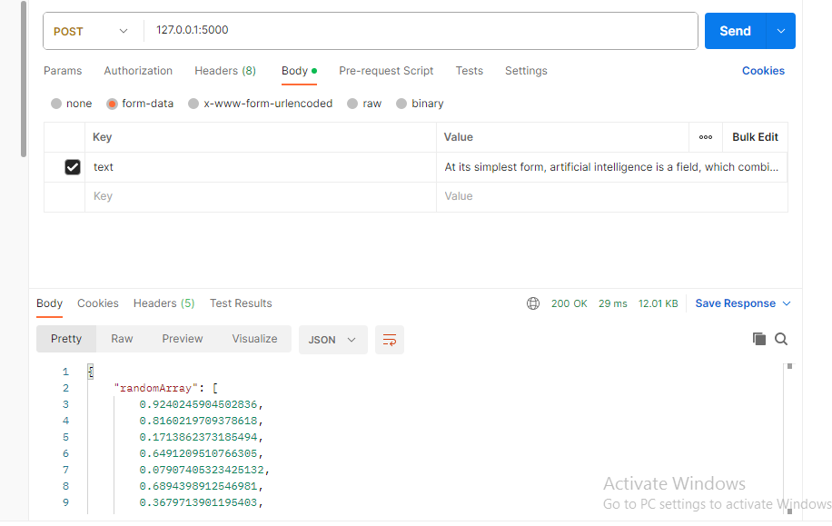

**Negative Test Cases:**

Case 1: Blanks are not allowed

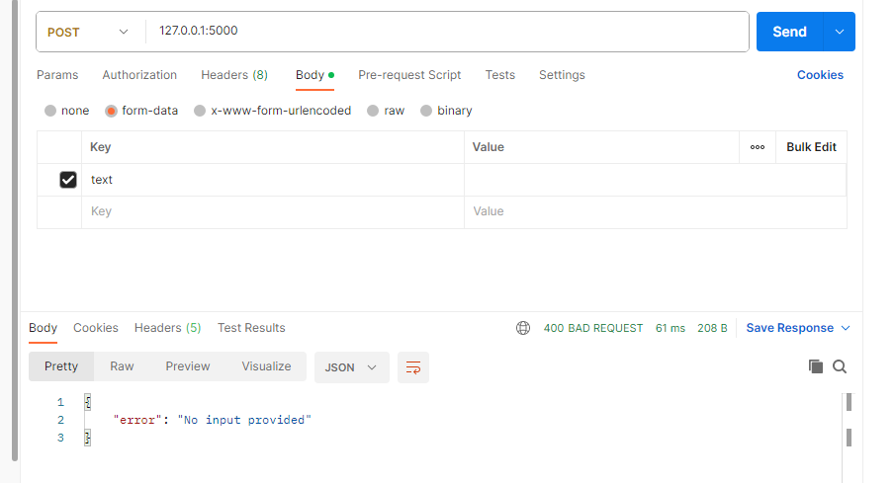

Case 2: Single word not allowed

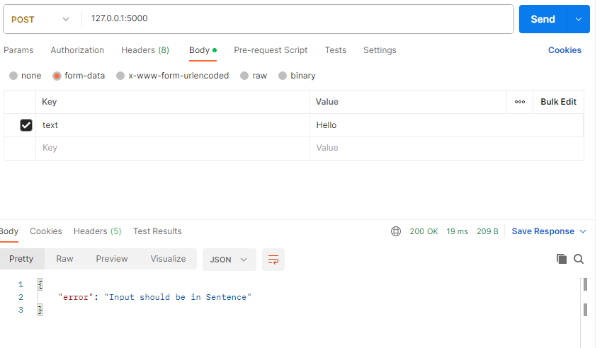

Case 3: Numbers and special characters are not allowed

